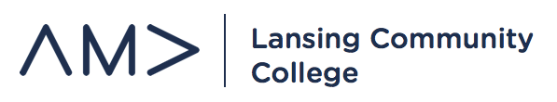
General Member Meeting
February 5, 2020
- Marketing Week – Membership
  - Next week? Updates?
  - Fundraising Fair – February 13th – Gannon Highway

- Concessions - Fundraising
  - Basketball Games
  - Sign-up with Patrick!
  - LCC One Book Movie Concessions – April 2nd, 5-7pm

- MBN Luncheon – Professional Development
  - February 20th – 11:00am – 1:30pm – MSU University Club
  - Jacqueline Baker – Director of Innovation and Programming AARP

- NOLA International Collegiate Conference – Professional Development
  - March 12-14th – New Orleans, LA
  - AMA Member List – are you an official AMA member?
  - Confirm group registrations
  - Travel arrangements – flight, hotel, registrations
  - Competitions – sign-up at www.ama.org/collegiate-awards-competitions/
  - T-Shirts – where are we on this?

- RSO Workshop – Community & Social Impact
  - Presentation/workbook update
  - Set date/time for workshop

- Star Tank – Professional Development
  - April 1st – 8am-12pm – West Campus
  - Discuss promo plan and getting participants
  - The Lookout and LCC Radio – where are we?

- Ele’s Place Video – Community and Social Impact
  - Update

- E-Board Meetings – Chapter Operations
  - Thursdays – 4:00pm – 5:00pm
  - A&S 1117 – Front Conference Room

