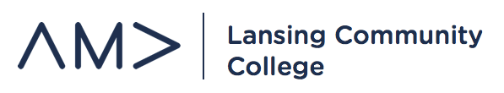
General Member Meeting
October 16, 2019
ICE BREAKER ACTIVITY

UPCOMING EVENTS:
- Competition Deadlines – Chapter Operations
  - Website Competition – deadline for registration – October 30th
  - Outstanding Marketing Week Competition – October 30th

- Concessions - Fundraising
  - Basketball Games – Wednesday, October 23rd – 7:00pm – Gannon 3rd Floor
  - Final Volleyball Games - Tuesday, October 22nd and 29th – 6:00pm – Gannon 3rd Floor
  - Edward Jones Holiday Party – Sunday, December 8th, evening

- Etiquette Dinner – Professional Development
  - New sponsor opportunities
  - Invitation and sponsor levels

- Regional Conference Update – Professional Development
  - Debrief
  - Approve expenses - $29.85 pizza meeting and $759.75 for Regional Conference

- Ferris State University Regional Conference – Professional Development
  - Friday, October 25th – register, participate in competitions

- RSO Halloween Party – Membership
  - Friday, October 25th – 7pm – GB 2214
  - Halloween gams, pizza and snacks, music, pumpkin painting, costume contest

- MBN Business Luncheon – Professional Development
  - October 30th, 2019 – 11am-2pm – MSU University Club
  - Sports Business Luncheon – Tom Dickson
  - Sign-up

- E-Board Meetings – Chapter Operations
  - Thursdays – 4:00pm – 5:00pm
  - GB 1240

