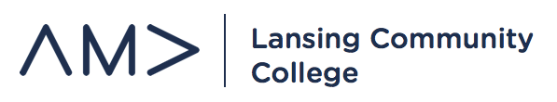
General Member Meeting
September 11, 2019
ICE BREAKER ACTIVITY

UPCOMING EVENTS:
- Northwood University Auto Show – Professional Development
  - September 27th – bus leaving LCC to Midland early morning
  - Breakfast, lunch, auto show
  - Sign-up to attend

- Classroom Visits – Membership
  - Need to begin visiting classrooms
  - Materials – Promo sheets, sign-up sheets, video on website

- Student Summit on Diversity and Inclusion – Professional Development
  - Friday, September 20th – 8am-2pm - LCC
  - Workshops and activities covering a variety of topics. Breakfast and lunch served
  - Attendees – Angela, Kaleigh, Devon, Eric, Stherlyne

- Lansing 5:01 Downtown Student Welcome Event – Membership
  - Saturday, September 21st – 4pm-7pm – Cooley Stadium
  - Student interest committee working on recruiting businesses

- Volleyball Concessions - Fundraising
  - September 17th – 5:30pm – Gannon 3rd Floor
  - Sign-up to volunteer

- Regional Conference Update – Professional Development
  - Tickets on sale in Student Life - $10
  - Promotions in process
  - Perfect Pitch sponsor update

- E-Board Meetings – Chapter Operations
  - Thursday’s – 4:00pm – 5:00pm
  - A&S 1117 – front conference room
  - Chapter Plan work

